TO A BLOODY PULP

A SAVAGE WORLDS CAMPAIGN

GOTHAM CITY, 1934

GUN CATALOGUE

DRAFT #2

By David Nelson
TO A BLOODY PULP
THE BIG BOOK OF PULP ERA GUNS

Caliber: type of bullet (no game effect)
Range: short/medium/long expressed in inches on the tabletop
Damage: damage points scored; AP: armor piercing effect
ROF: number of shots that can be taken (-2 to hit if you take more than 1)
Auto-Select: this fully automatic weapon can be set to fire single shots as well.
Semi-Auto: semi-automatic that can make the double-tap action
Revolver: cannot make a double-tap
Bolt-Action: cannot make a double tap
Lever-Action: cannot make a double tap
Pump Action: cannot make a double tap
Double-Barreled: may make a double-tap but automatically must reload next round
Hi-Recoil: it requires a full turn to fire the weapon (no movement)
Encumbrance: the encumbrance level of the weapon, including 50 bullets (or 100 for an automatic weapon)
Vehicle Mount: must be mounted on a vehicle or emplacement or carried and assembled by a crew of 3 (or 2 really strong guys)
HW: counts as a Heavy Weapon, for attacking armored vehicles etc.
Snapfire Penalty: shooter suffers -2 to hit if he moves the same turn as firing
Min Str: the minimum strength score needed to fire the weapon
Thompson Submachinegun (US)  Caliber: .45 ACP Range: 12/24/48  Damage: 2d6+1 AP1  ROF: 3 Auto-Select  Encumbrance 18  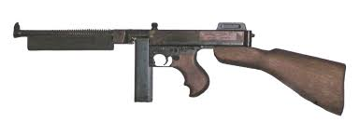 | Browning Automatic Rifle (B.A.R) (US)  Caliber: .30 Range: 24/48/96  Damage: 2d8 AP2  ROF: 2 Auto-Select  Encumbrance 25 Min Str 1d8  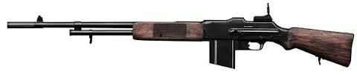
Colt 1911 (US)  Caliber: .45 ACP Range: 12/24/48  Damage: 2d6+1 AP1  ROF: 1 Semi-Auto  Encumbrance 8  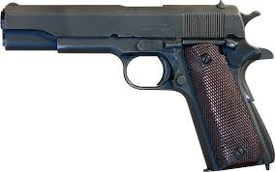 | M1919 Machinegun (US)  Caliber: .30 Range: 24/48/96  Damage: 2d8 AP2  ROF: 3 Hi-recoil  Encumbrance 40  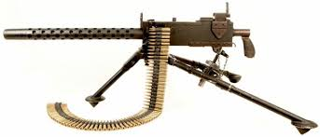

M2 .50 Machinegun (US)  Caliber: .50 Range: 50/100/200  Damage: 2d10 AP4  ROF: 3 Vehicle Mount, HW  Encumbrance 90  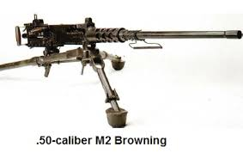 | Colt New Service Revolver (US)  Caliber: .45 Range: 12/24/48  Damage: 2d6+1 AP1  ROF: 1 Revolver  Encumbrance 7  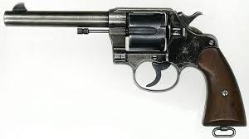
Colt Police Positive Revolver(US)  Caliber: .32 Range: 10/20/40  Damage: 2d6 AP0  ROF: 1 Revolver  Encumbrance 3  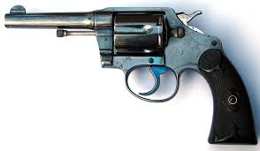 | Smith and Wesson Police(US)  Caliber: .38 special Range: 12/24/48  Damage: 2d6 AP1  ROF: 1 Revolver  Encumbrance 5  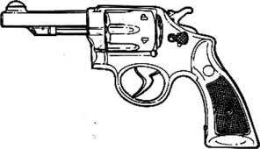
FN Vest Pocket (US)  Caliber: .25 Range: 6/12/24  Damage: 1d6+1 AP0  ROF: 1 Semi-Auto  Encumbrance 2  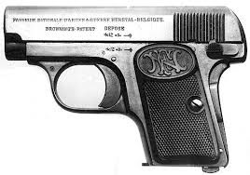 | M1 Garand (US) prototypes only  Caliber: .30 Range: 24/48/96  Damage: 2d8 AP2  ROF: 1 Semi-Auto  Encumbrance 15 Min Str 1d6  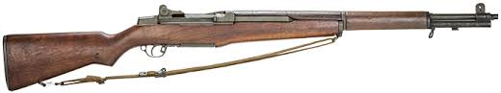
Springfield Rifle (US)  Caliber: .30 Range: 24/48/96  Damage: 2d8 AP2  ROF: 1 Bolt-Action  Encumbrance 18 Min Str 1d6  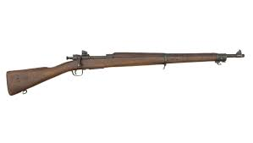 | Colt Peacemaker (US)  Caliber: .45 Range: 12/24/48  Damage: 2d6+1 AP0  ROF: 1 Revolver  Encumbrance 8  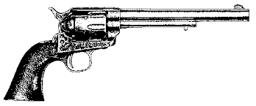

Remington M30 Hunting Rifle (US)  Caliber: .32 Rem Range: 24/48/96  Damage: 2d6+1 AP1  ROF: 1 Bolt-Action  Encumbrance 14 Min Str 1d6  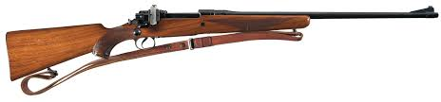 | Remington M8 Hunting Rifle (US)  Caliber: .25 Rem Range: 24/48/96  Damage: 2d6 AP0  ROF: 1 Semi-Automatic  Encumbrance 12 Min Str 1d6  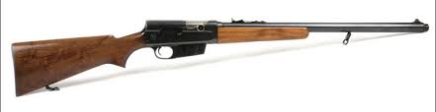
Winchester M1892 Rifle (US)  Caliber: .32-20 Range: 24/48/96  Damage: 2d6 AP1  ROF: 1 Lever-Action  Encumbrance 13 Min Str 1d6  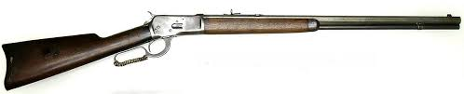 | Winchester M1894 Carbine(US)  Caliber: .32-40 Range: 20/40/80  Damage: 2d6 AP0  ROF: 1 Lever-Action  Encumbrance 11 Min Str 1d6  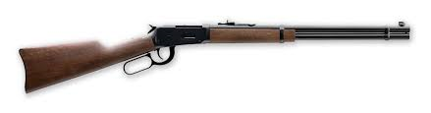

Remington M11 Police Shotgun (US)  Caliber: 12-gage Range: 12/24/48  Damage: 1d/2d/3d AP0  ROF: 1 Semi-Automatic  Encumbrance 13  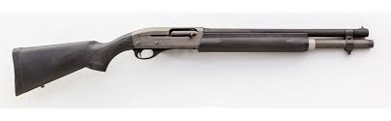 | Remington M31 Shotgun (US)  Caliber: 12-gage Range: 12/24/48  Damage: 1d/2d/3d AP0  ROF: 1 Pump-Action  Encumbrance 13  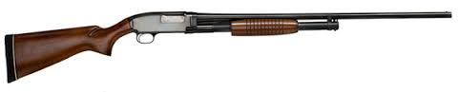
Remington M32 Shotgun (US)  Caliber: 12-gage Range: 12/24/48  Damage: 1d/2d/3d AP0  ROF: 1 Double-Barreled  Encumbrance 11  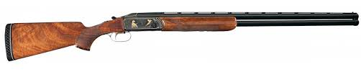 | Sawed-Off Shotgun (US)  Caliber: 12-gage Range: 5/10/20  Damage: 1d/2d/3d AP0  ROF: 1 Double-Barreled  Encumbrance 6  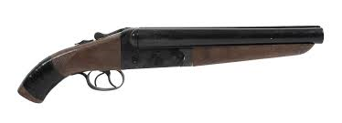

Lee Enfield #4 Rifle (UK)  Caliber: .303 Range: 24/48/96  Damage: 2d8 AP1  ROF: 1 Bolt-Action  Encumbrance 17 Min Str 1d6  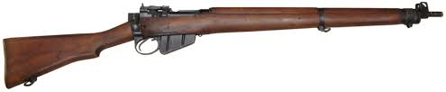 | Webley Revolver (UK)  Caliber: .455 Range: 12/24/48  Damage: 2d6+1 AP2  ROF: 1 Revolver  Encumbrance 8  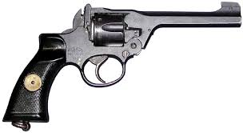
Vickers Machinegun (UK)  Caliber: .303 Range: 24/48/96  Damage: 3d6 AP2  ROF: 3 Hi-recoil  Encumbrance 43  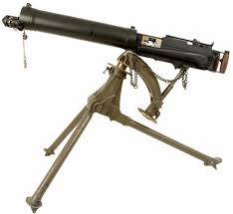 | Nitro Express Elephant Rifle (UK)  Caliber: .577 nitro Range: 30/60/120  Damage: 2d10 AP2  ROF: 1 Double Barreled  Encumbrance 20 Snapfire Penalty  Min Str 1d8  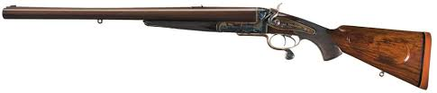

Lugar P08 (German)  Caliber: 9mm Range: 12/24/48  Damage: 2d6 AP1  ROF: 1 Semi-Auto  Encumbrance 7  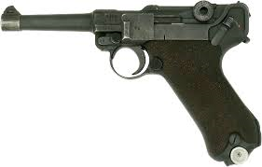 | KAR 98k Rifle (German)  Caliber: 7.92mm Range: 24/48/96  Damage: 2d8 AP2  ROF: 1 Bolt-Action  Encumbrance 16 Min Str 1d6  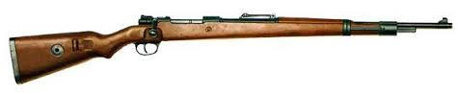
Steyr-Slothurn SMG (German)  Caliber: 9mm Range: 12/24/48  Damage: 2d6 AP1  ROF: 3 Auto-Select  Encumbrance 16  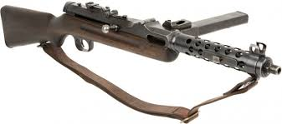 | MG34 Machinegun (German)  Caliber: 7.92mm Range: 24/48/96  Damage: 3d6 AP2  ROF: 3 Hi-recoil  Encumbrance 38 Min Str 1d8  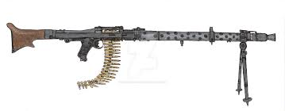

Nambu Pistol (Japanese)  Caliber: 8mm Range: 10/20/40  Damage: 2d6 AP0  ROF: 1 Semi-automatic  Encumbrance 3  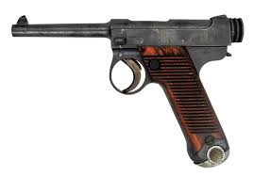 | Arisaka Rifle (Japanese)  Caliber: 6.5mm Range: 24/48/96  Damage: 2d6+1 AP1  ROF: 1 Bolt-Action  Encumbrance 14 Min Str 1d6  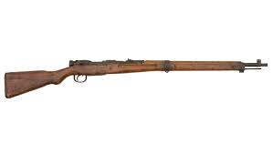
Moisin-Nagant Rifle (Russian)  Caliber: 7.65mm Range: 24/48/96  Damage: 2d8 AP2  ROF: 1 Bolt-Action  Encumbrance 18 Min Str 1d6  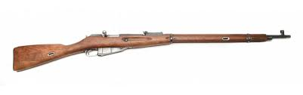 | Tokarev Pistol (Russian)  Caliber: 7.62mm Range: 12/24/48  Damage: 2d6 AP1  ROF: 1 Semi-Auto  Encumbrance 7  