TO A BLOODY PULP

A SAVAGE WORLDS CAMPAIGN

GOTHAM CITY, 1934

GEAR SUPPLEMENT #1
A random grab bag of weapons and adventure gear

By David Nelson

Lewis Light Machine Gun (UK)  Caliber: ..303 Range: 24/48/96  Damage: 2d8 AP 2  ROF: 3 Hi-Recoil  Encumbrance 30 Min Str 1d8  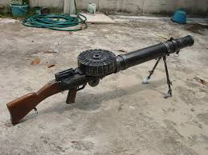 | Mercy Pistol Bullets Mark 2  Encumbrance 1  Effect: These bullets in a pistol or submachine-gun always do 1d6 of non-lethal damge  *C-1 (used up when 1 on shooting roll comes up)  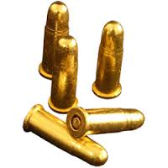
Savage Brand Mercy Bullets  Encumbrance 2  Effect: These bullets in a pistol or submachine-gun always do no damage, but target who is hit must make a Vigor check or fall unconscious for 10-40 minutes  *C-1 (used up when 1 on shooting roll comes up)  These bullets are designed and produced by Clark Savage and his band of do-gooders in New York and are small glass capsules with a powerful anesthetic liquid inside | Savage Super Machine Pistol  Caliber: .20 Range: 12/24/48  Damage: 1d6 AP 0  ROF: 3 Auto-select  Encumbrance 7  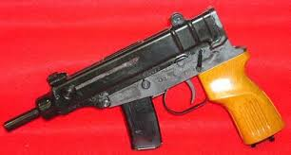  Special: designed by Clark Savage, usually uses special mercy bullets; can do full auto without auto-fire penalty

Mauser C98 (German)  Caliber: 755mm Range: 12/24/48  Damage: 2d6 AP 2  ROF: 1 Semi-Auto  Encumbrance 9  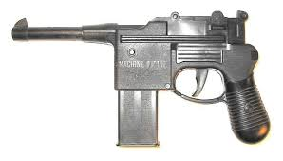 | Cigar-Lighter Dart Shooter  Encumbrance 1  Range: 2/4/6  Effect: disguised as a cigar lighter, this has two uses, an unwitting user will shoot himself in the hand when using it a lighter. By a familiar user it can be used as a dart gun (requires called shot to hand (-2) or other exposed flesh to penetrate) In either case, the dart must first be treated with some sort of venom. The lighter can hold 4 darts.  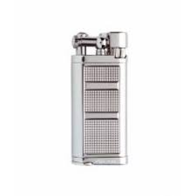
Deadly Venom  Encumbrance 1  Effect: a deadly poison that must be injected into blood stream to have effect. The bottle has enough venom to make 8 attacks (applied to dart, arrow, knife etc, one use per weapon) On a hit that penetrates—a shaken result with a weapon, or a hit on exposed skin by smalll dart, causes target to save vs. Vigor or immediately take 4 wounds.  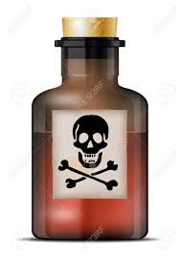  *C-8 | Paralytic Venom  Encumbrance 1  Effect: a paralytic agent that must be injected into blood stream to have effect. The bottle has enough venom to make 8 attacks (applied to dart, arrow, knife etc, one use per weapon) On a hit that penetrates—a shaken result with a weapon, or a hit on exposed skin by small dart, causes target to save vs. Vigor or immediately become paralyzed for 1 hour.  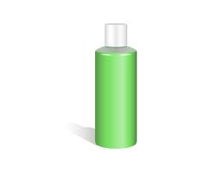  *C-8

Dart Rifle  Caliber: dart Range: 15/30/45  Damage: 2d6 AP 0  ROF: 1 bolt action  Encumbrance 12  Air-powered and Silent, uses darts that must be filled with some sort of venom  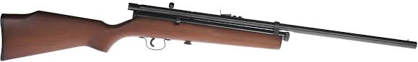 | Climbing Suction Cups  Encumbrance 5  Effect: allows someone to climb up smooth surfaces (glass or concrete buildings mostly) with a +4 to climb checks  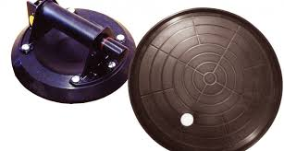
Tranquilizing Venom  Encumbrance 1  Effect: a sleep-producing agent that must be injected into blood stream to have effect. The bottle has enough v to make 8 attacks (applied to dart, arrow, knife etc, one use per weapon) On a hit that penetrates—a shaken result with a weapon, or a hit on exposed skin by small dart, causes target to save vs. Vigor or fall asleep for 1-4 hours  *C-8 | Rope Ladder 50’  Encumbrance 35  Effect: allows someone to climb up or down without making a climb check  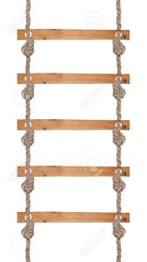

RADIO SIGNAL LOCATOR  Encumbrance 75  Effect: can locate the source of a radio transmission within a 10 miles radius  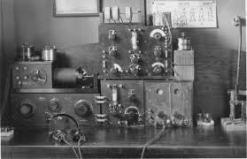 | INFRARED GOGGLES  Encumbrance 1  Effect: allows wearer to see targets illuminated by an infrared lamp.  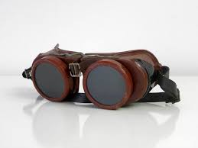
INFRARED LAMP  Encumbrance 5  Effect: illuminates an area 24” long and 6” wide with infrared light. People with infrared googles can see anything in this area as if in daylight.  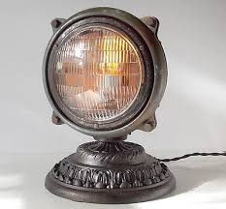 | INFRARED DYE SRAY  Encumbrance 1  Effect: target sprayed by dye and illuminated with an infrared lamp, will be visibly marked to anyone viewing with infrared goggles  *C-8  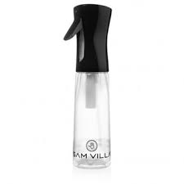

SEMAPHORE LAMP  Encumbrance 3  Effect: allows coded communication at line of sight.  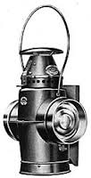 | Savage Gadget Vest  Encumbrance 2-empty, 7-loaded  Effect: a scientifically designed (by Clark Savage) vest with an array of pockets, straps, etc, that allows the user to carry a variety of small objects easily. Up to 10 objects each of Encumbrance 1 or less can be carried at half listed encumbrance value.  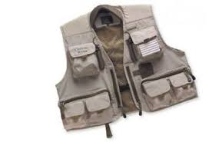
Savage Mesh Vest  Encumbrance 9  Armor Value: +3  Coverage: torso  Effect: a special metallic mail vest designed by Clark Savage which gives equal light-weight protection against all sorts of attacks.  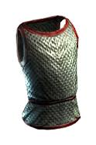 | Cigar-Lighter Flame Thrower  Encumbrance 1  Range: 2/4/6  Effect: disguised as a cigar lighter, this device shoots off a fire attack, hitting a small burst template, doing 3d6 damage.  *C-1

Two-Way Wrist Radio  Encumbrance 0  Effect: A portal radium-powered, two-way radio with a 2 mile range, configured as a wrist watch.  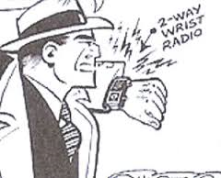 | Experimental Rocket Pack  Encumbrance 15  Effect: gves the wearer the power to fly (using pilot skill) for 30 minutes with a max speed of 48, Acceleration of 12, Climb 6  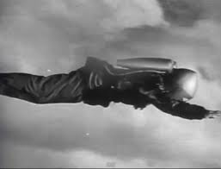
Dictaphone  Encumbrance 5  Effect: records conversation on wax or plastic cylinder for later play-back  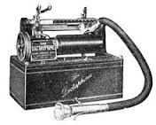 | Wire Recorder  Encumbrance 5  Effect: records conversation on spool of wire for later play-back  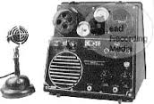

Baseball Bat  Encumbrance 2  Damage: Str+1d6 (2 hands)  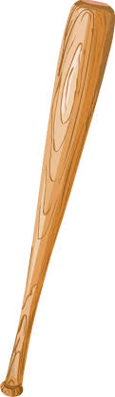 | Motorcycle Helmet  Encumbrance: 3  Armor: 2  Coverage: head (75%)  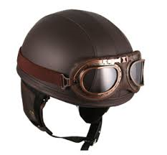
Paraglider  Encumbrance 40  Use: gives a gliding pace of 6”, with 1” drop in altitude for each 2” of movement. A pilot roll allows for maintaining level flight; a raise allows a 1” climb. Landing requires a pilot check, with a roll of 1 meaning a crash (regardless of wild die), wrecking the glider and inflicting 1 wound on the pilot.  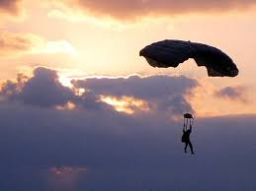 | Puma Brand Pomade  Encumbrance: 0 *C-8  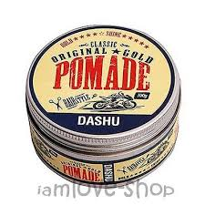
Hornet Gas Gun  Caliber: gas Range: 2/4/6  Damage: special AP 0  ROF: 1  Encumbrance 5  The gun fires a stream of anesthetic gas, if hit, target makes a Vigor roll or falls unconscious (if shot was a raise, Vigor is -2) .  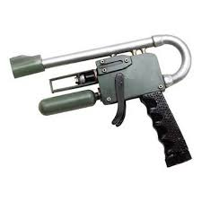 | Combat Boomerang  Range: 6/12/24  Damage: Str+1d4  ROF: 1  Encumbrance 1  Can also be used as a grappling hook  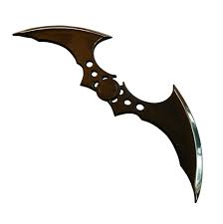
Land Mine (Pressure)  Encumbrance 3  Use: when stepped upon explodes in medium burst template for 3d6 damage. Can also be rigged to fire by a trip wire or other mechanical booby-trap.  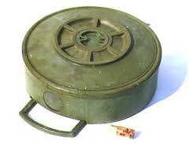 | Land Mine (Remote)  Encumbrance 3  Use: when operator electrically activates trigger (demolition kit), by a wire connection, explodes in medium burst template for 3d6 damage. Multiple mines can be wired to the same trigger

